Determinants of India’s Economic Growth
Andrew Wheaton
ECON 306 - 001
12/8/2025

This paper analyzes the determinants of India’s economic growth since independence through a time-series study. The study explores how key variables–such as trade, population, index of democratization, and age dependency ratio–have contributed to India’s emergence as a global economic power. Drawing on decades of data, it traces the transformation of India’s growth trajectory through liberalization and globalization. By analyzing the drivers of India’s
economic growth, this study provides insights into India’s evolving economic model and its
implications for the future dynamics of the global economy.

India’s transformation into one of the world’s fastest-growing economies has drawn global attention as a model of large-scale, multidimensional development. Since gaining independence in 1947, India has grown from a heavily regulated, internally focused economy to a dynamic, globally integrated one. Today, the country ranks among the largest economies in the world and plays an increasingly central role in trade, technology, and geopolitical affairs. Understanding the drivers of this growth is essential not just to interpreting its economic past but also for forecasting its trajectory in the global economy.
India’s economic expansion has been driven by a combination of economic and demographic forces. The story of the Tata Group, one of India’s most influential conglomerates, encapsulates this transformation. As Raianu (2021) describes in Tata: The Global Corporation That Built Indian Capitalism, the company’s evolution from a colonial-era industrial enterprise to a global corporate powerhouse mirrors the broader trajectory of India’s economic modernization. Tata’s expansion into technology, steel, and international consultancy reflects the same liberalization, globalization, and institutional adaptation that have shaped the nation’s rise. This corporate perspective illustrates how the macro-level forces analyzed in this study manifest at the firm level, and it grounds the study in a tangible narrative.
A crucial aspect of India’s growth has been its growing involvement in global markets through trade. During the 1980s, India financed its rising fiscal deficits through external borrowing, while maintaining a highly protectionist economic structure. By the end of the decade, public debt rose to around 60% of GDP, inflation accelerated, and exports stagnated. Investor confidence in the domestic market suffered in response to political instability, and the nation faced the real prospect of sovereign default. Indian policymakers responded to this crisis, known as the 1991 Balance of Payments crisis, with economic liberalization that reduced tariffs, deregulated industries, and encouraged foreign investment. In their article Trade Openness and Economic Growth: Empirical Evidence from India, Hye and Lau (2015) use time-series analysis to demonstrate that trade liberalization has had a statistically significant and positive effect on GDP growth in both the short and long run. The reason for this effect is that trade openness increases accessibility to global technology and expands opportunities for export growth. This empirical relationship provides the basis for including trade openness (wdi_trade) as a key explanatory variable in this paper’s regression.
Another important dimension of India’s transformation lies in its demographic structure. With a median age of 28, India has a much more youthful population than countries like China with a median age of 39 or the United States with a median age of 38 (Pew Research), and this presents a significant economic advantage. Aiyar and Mody (2011) provide strong evidence of this in their IMF paper The Demographic Dividend: Evidence from the Indian States, where they find that variations in the working-age population ratio significantly explain differences in per-capita income growth across Indian states. For this reason, measures such as population (wdi_pop) and the age dependency ratio (wdi_agedr) are included in this study’s model to capture the effect of demographic change on India’s GDP growth.
While trade and demographics highlight structural dimensions of growth, India’s political framework has also played a defining role. Patnaik (2013), in Democracy and Economic Growth in India, argues that democratic governance has fostered stability and investor confidence, which are both conditions that are essential for sustained long-term growth. This makes the index of democratization (van_index) an especially relevant variable in examining India’s growth because it captures how institutional quality and political stability may reinforce economic progress.
This study employs a time-series approach to analyze the determinants of India’s economic growth since independence. The dependent variable is real GDP growth rate (wdi_gdpgr), representing the annual percentage change in India’s gross domestic product. GDP growth captures the overall performance of the economy and thus fits well in this model.
The independent variables were selected based on the referenced literature that demonstrated their significance in this model. These include trade openness, population, age dependency ratio, and index of democratization. Each represents a major dimension of India’s development and aligns with prior studies such as Hye and Lau, Aiyar and Mody, Patnaik, and Raianu.
Trade openness is measured as the sum of imports and exports as a percentage of GDP. According to the referenced sources, greater trade openness is expected to have a positive effect on GDP growth by promoting greater specialization, technology transfer, and market efficiency (Hye and Lau 2015).
Population, measured as the total national population, captures the scale of the domestic market and labor force, and either one of those can stimulate production. While India’s youthful population has been cited as a key contributor to its economic growth, the impact of the population on the economy can vary depending on the dependency burden and employment capacity of the economy. Importantly, the population variable has been converted into its natural logarithm to model proportional changes rather than absolute levels. This conversion stabilizes variance and allows for the changes in population to be interpreted proportionally.
The age-dependency ratio is the ratio of dependents (age 0-14 and 65+) to the working age population (ages 15-64), so it measures the demographic pressure on the labor force. A lower dependency ratio is indicative of more workers contributing to the country’s output, and this is associated with faster economic growth (Aiyar and Mody 2011). Conversely, shifts in age structure produce a greater economic burden when the population ages because having more dependents puts greater pressure on the working age population to produce the necessary output with fewer workers. Therefore, including the age-dependency ratio is important to the integrity of this model to make sure the benefits and restraints are taken into consideration. The expected sign on the coefficient for this variable is negative which would indicate that economic expansion slows as the ratio increases.
The index of democratization serves as a proxy for institutional quality and stability, and it is an indicator of political rights, electoral competition, and governing characteristics. Greater democratization can have a positive effect on GDP when it is associated with deregulation of industries and greater openness to foreign trade. However, an excessive increase of democratization can have a negative effect as it can widen the gap between socioeconomic classes. As this model primarily observes the period in which India went from a protectionist economic structure to an economy more open to trade, the expected coefficient is positive to indicate greater economic expansion as the result of greater democratization.
The first step of this study was to observe whether each variable moved in a stable, predictable way over time so that false conclusions could be avoided. This property of stationarity was tested using the Dickey-Fuller test, which measures whether variables have a constant pattern over time or drift unpredictably. The results shown in Table A2 indicate that real GDP growth is stationary. However, the independent variables–age dependency ratio (Table A3), trade openness (Table A4), log population (Table A5), and index of democratization (Table A6)–are non-stationary. To avoid spurious results, these non-stationary variables were transformed into first differences, which converted them from drifting variables into variables that reflect annual changes and are more reliable for time-series modeling. This transformation removes long-term trends that could incorrectly make two unrelated variables appear correlated. The resulting variables from this process were d_trade, d_agedr, d_ln_pop, and d_van_index. These transformations ensure that the variables are all stationary, which is a necessary condition for unbiased time-series estimates.
After addressing stationarity, the next step was to determine whether GDP and trade openness share a long-run equilibrium relationship, a property known as cointegration. This was assessed through the Engle–Granger cointegration test which estimated the long-run relationship between these two variables and then tested whether the residuals are stationary. Table A7 shows that this test resulted in a test statistic of -1.767 and a p-value of 0.7206, which are well above the critical values required for stationarity. If the residuals were stationary, this would indicate that GDP and trade move together over the long-term, and this would require another model to be used. However, the results prove that the residuals are non-stationary, so GDP growth and trade are not cointegrated. This result is significant because it proves that there is no equilibrium relationship that is pulling the two variables towards each other over time.
To identify whether India’s economic growth experienced a sudden, significant shift during the observed period, a structural break test was conducted. Instead of assuming a predetermined break date, such as 1991 (India’s widely recognized liberalization), the estat sbsingle method that was used searched for an unknown structural break within the data. The test revealed a break in 1980, as shown in Table A9, which indicates that the underlying growth relationship changed during this period. This finding aligns with Raianu’s (2021) account of India’s economic evolution, which highlights how corporate behavior and institutional attitudes toward market-oriented activity were already shifting in the 1980s. This helps to explain why the break was identified as happening before the more formal liberalization that took place in 1991 and the following years.
Next, Granger causality tests were conducted to observe whether changes in trade, demographics, or democratization help predict changes in GDP growth. The vector autoregressions (VAR) framework allows each variable to depend on its own past values and the past values of the other variable, allowing it to capture dynamic relationships. Table A10 shows that trade openness Granger-causes GDP growth, as indicated by a statistically significant chi-square statistic less than .01, but GDP does not Granger-cause trade openness. This result suggests that changes in trade flows help predict future economic performance, but changes in GDP growth do not influence India’s trade openness. Table A11 shows that the age dependency ratio Granger-causes GDP growth with a p-value less than .001, but GDP growth does not Granger-cause the ratio. This result indicates that demographic shifts contain predictive information about future changes in economic growth, but that fluctuations in the GDP cannot be used to predict the future population. Finally, Table A12 shows that the index of democratization Granger-causes GDP growth with a p-value less than .01, while GDP does not Granger-cause democratization. This relationship suggests that institutional and political developments help predict future changes in economic performance, but these developments evolve independently of short-term economic fluctuations. These unilateral relationships demonstrate that each of these variables help predict GDP growth in India, but GDP growth does not predict movements in any of these variables.
After establishing stationarity, verifying absence of cointegration, identifying structural breaks, and determining Granger-causal direction, the final step was to estimate the short-run growth model. The short-run regression was estimated using robust standard errors to account for potential non-constant variance in the error term.

$$wdi_gdpgr = α+ β1 d_trade + β2 d_agedr + β3 d_ln_pop + β4 d_van_index + ε$$

This model uses GDP growth as the dependent variable and the differenced explanatory variables as predictors. This final model provides the empirical basis for evaluating the short-run effects of trade openness, demographic change, population growth, and democratization on India’s economic growth.
The results from this model, as shown in Table A13, indicate that population growth is the most influential driver of India’s economic performance, as the coefficient on the first difference of log population is the only statistically significant variable at the 5% level. With a negative coefficient (-234.0903), the model shows that increases in population growth place downward pressure on India’s GDP growth, likely because rapid population expansion strains India’s resources and dilutes capital. Trade openness exhibits a marginally significant effect on GDP growth at the 10% level. With a negative coefficient (-.1742), this model suggests that increases in trade flows decrease India’s GDP growth. While trade liberalization is associated with long-run GDP growth in the cited sources, this negative effect could be the result of abrupt increases in trade flows creating short-run adjustment costs. While neither is significant at the 5% or 10% levels, the coefficients on the age dependency ratio and the index of democratization have the expected signs–negative for dependency and positive for democratization. This result reflects the slow-moving nature of demographic and institutional changes, while also confirming the conclusions of Aiyar and Mody (2011) as well as Patnaik (2013) that long-term shifts in population structure and democratic governance positively influence economic performance.
The empirical findings from this study offer a nuanced understanding of the forces shaping India’s economic growth. One of the most striking results is the dominant role of population growth in the short-run model. The negative and statistically significant coefficient suggests that rapid increases in population growth depress GDP growth in the short term. This finding is intuitive when viewed through the lens of India’s evolving economic structure: sharp increases in population place immediate pressure on housing, public services, job creation, and infrastructure. When this population growth outpaces the economy’s ability to find new workers, per capita output falls, and households may experience decreasing living standards. While India’s demographic dividend is cited as a long-run asset by Aiyar and Mody (2011), the results of this model highlight the short-run challenges that must be managed.
Trade openness also presents a complex picture. While Hye and Lau (2015) conclude that trade liberalization has a positive effect on GDP growth in the long-run, this short-run regression model indicates that sudden increases in trade openness can reduce GDP growth. This is possibly the result of trade expansion prematurely exposing domestic companies to foreign competitors, especially companies that were previously a part of protected sectors. Additionally, adjustment costs like restructuring and exchange rate fluctuations can occur before the benefits of increased trade materialize. Therefore, the negative coefficient suggests that trade liberalization produces transitional friction, but it enables long-run GDP growth.
From a policy perspective, these findings emphasize the importance of pairing demographic opportunities with deliberate economic planning. A large and growing population can be an engine of growth only if new workers can be added to productive employment. Additionally, they need to be supported by adequate infrastructure. Policies that expand access to education, improve health outcomes, and encourage labor-intensive jobs can help transform population growth into higher output. Otherwise, this population growth can decrease living standards and output. Similarly, the short-run costs associated with trade openness suggest that liberalization policies should be accompanied by measures that ease adjustment. Such policies may include retraining programs or support for firms transitioning into more competitive environments. Without these complementary policies, demographic pressures and trade shocks may amplify short-run volatility even if they are beneficial in the long-run.
The lack of statistical significance for the age-dependency ratio and the index of democratization reflects the gradual nature of these changes. Demographic and institutional structures both develop slowly, over decades rather than single years, and are therefore unlikely to display meaningful effects year-to-year. However, the Granger causality results showing that both variables predict future GDP growth add to this interpretation that these variables shape the broader economic environment over the long-run, even if they do not directly influence short-run GDP fluctuations.
The structural break identified in 1980 provides further context for the findings by showing that India’s economic growth has not been constant over time. This break corresponds with shifts in political and institutional attitudes that preceded the formal liberalization of 1991. This turning point suggests that the drivers of growth evolved during this period, and that India’s economy may have entered a new growth regime characterized by different relationships between trade, demographics, institutions, and output. Recognizing this structural shift is important for understanding why short-run effects may differ across time and why certain variables require longer horizons to have significant influence.
This study set out to examine the key drivers of India’s economic growth since its independence. Using a time-series analysis, the study incorporates tests for stationarity, cointegration, structural breaks, and Granger causality before estimating a short-run regression model. The results reveal that population growth is the most significant short-run determinant of GDP growth, exerting a negative effect that reflects the challenges of managing rapid demographic expansion. Trade openness exhibits transitional adjustment costs in the short run, although evidence from Hye and Lau (2015) supports its positive long-term effects on GDP growth. Institutional quality and demographic structure, while not statistically significant in the short-run, demonstrate predictive power through the Granger causality analysis.
These findings suggest that India’s economic growth cannot be explained by short-run dynamics alone. Instead, the forces shaping growth operate on multiple time horizons. Long-run determinants such as demographic transition, institutional strengthening, and market liberalization play a crucial role in shaping the economic environment, while short-run fluctuations are driven by more immediate pressures such as population growth and trade openness.
While the model used in this study captures important short-run relationships, it does display several limitations. The analysis does not incorporate sector-specific data, labor market variables, or human capital measures that may further clarify growth patterns. Moreover, the focus on first differences, necessitated by stationarity requirements, limits the ability to estimate long-run elasticities. Future research could expand on this work by using structural models, multivariate cointegration approaches, or state-dependent frameworks that capture how India’s growth drivers evolve across different economic regimes.
Despite these limitations, the study contributes to a deeper understanding of the complex interplay between demography, trade, institutions, and economic growth in one of the world’s most consequential economies. The results underscore the importance of aligning short-run policy responses with long-run structural reforms to ensure that India can continue its current economic trajectory.

Appendix
Table A1: Summary Statistics
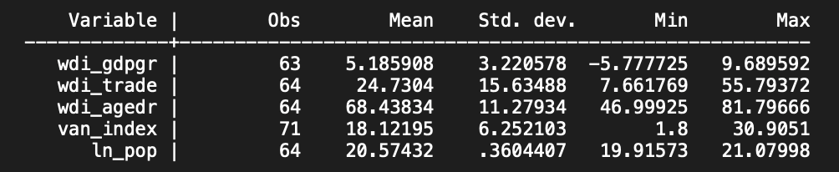

Table A2: DF Test - GDP
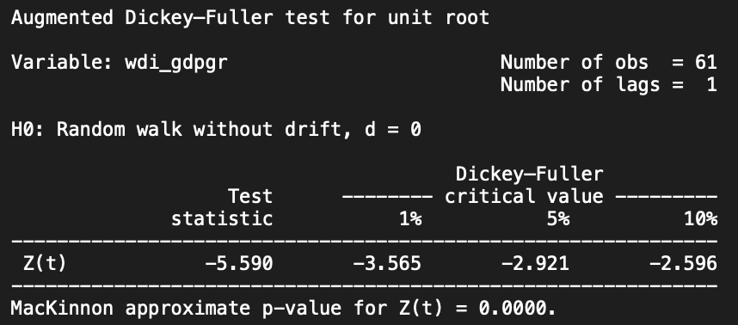

Table A3: DF Test – Age Dependency Ratio
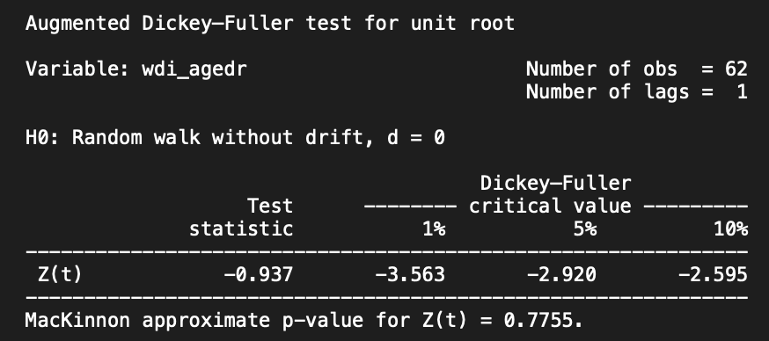

Table A4: DF Test – Trade Openness
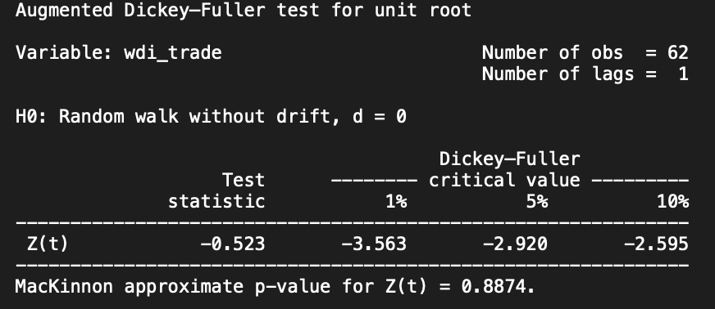

Table A5: DF Test - Population
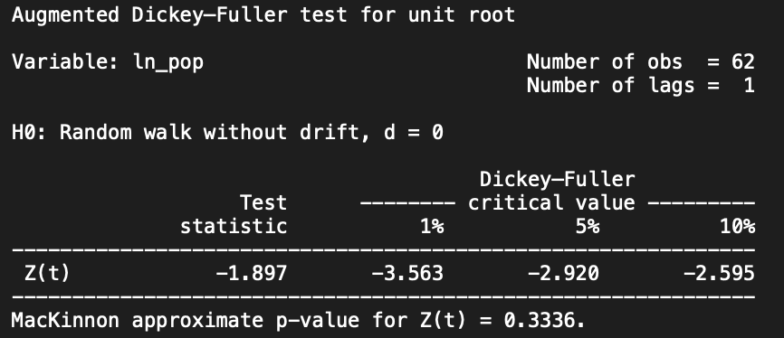

Table A6: DF Test – Index of Democratization
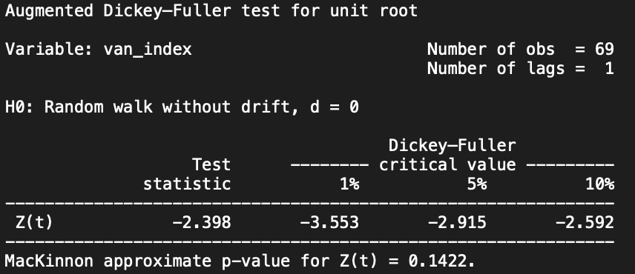

Table A7: Cointegration Test – DF Test on Residual
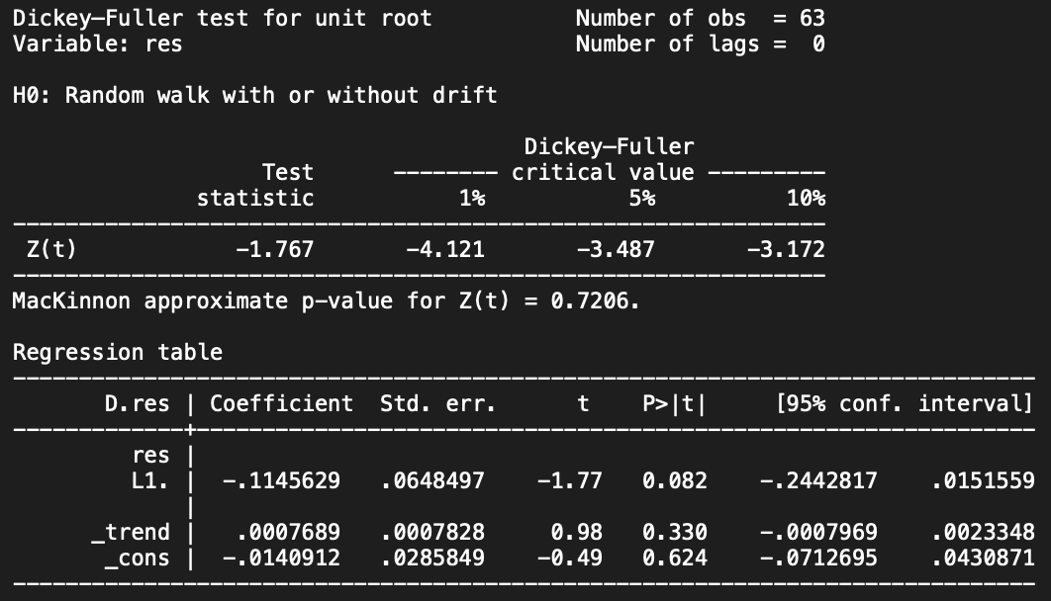

Table A8: Cointegration Test – DF Test without Constant
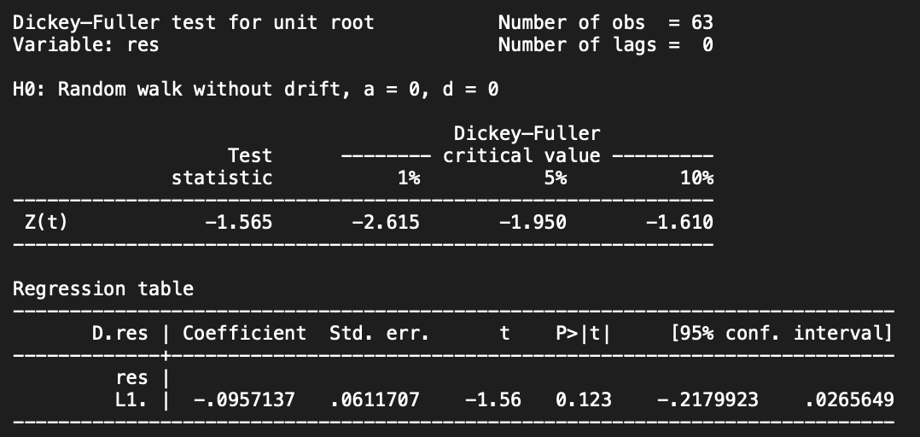
Table A9: Structural Break Test
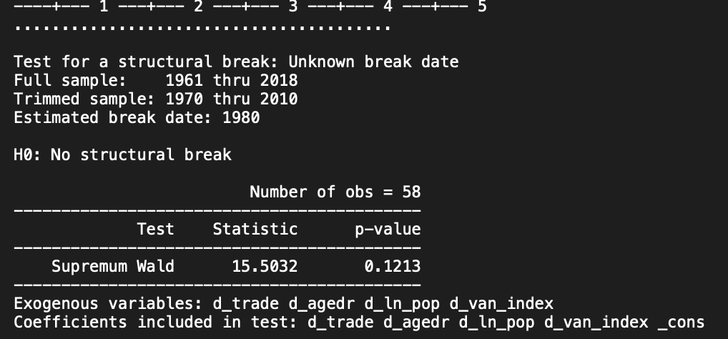

Table A10: Granger Causality Test – Trade and GDP
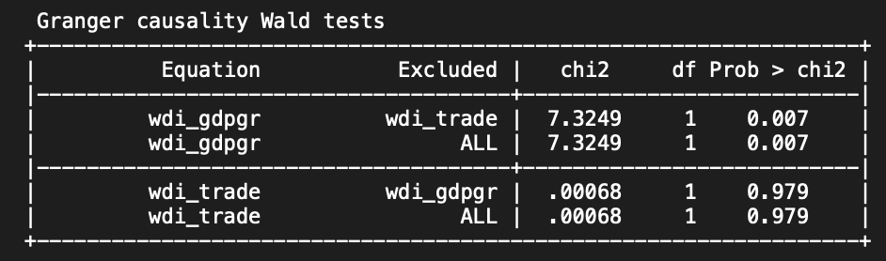

Table A11: Granger Causality Test – GDP and Age Dependency Ratio
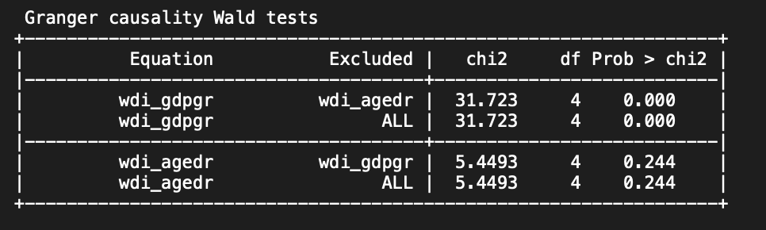

Table A12: Granger Causality Test – GDP and Index of Democratization
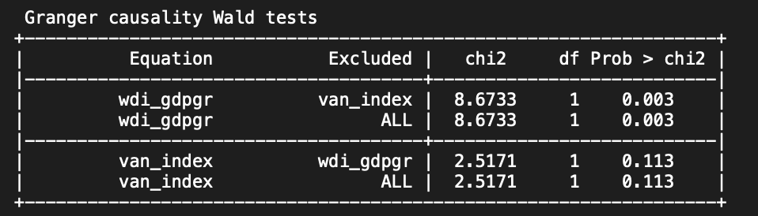

Table A13: Final Regression
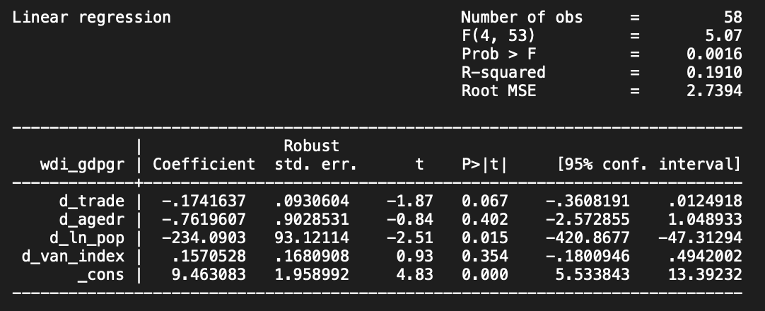

Sources
Aiyar, Shekhar, and Ashoka Mody. 2011. The Demographic Dividend: Evidence from the Indian
States. IMF Working Paper No. 11/38. Washington, DC: International Monetary Fund.
https://www.elibrary.imf.org/view/journals/001/2011/038/article-A001-en.xml
Hye, Qazi Muhammad Adnan, and Wong-Yuen Lau. 2015. “Trade Openness and Economic
Growth: Empirical Evidence from India.” Journal of Business Economics and
Management 16 (1): 188–205.
https://journals.vilniustech.lt/index.php/JBEM/article/view/2720/2231
Patnaik, Ila. 2013. Democracy and Economic Growth in India. Macro/Finance Research Group
Working Paper. New Delhi: National Institute of Public Finance and Policy.
https://macrofinance.nipfp.org.in/PDF/Patnaik2014_democracyGrowth.pdf
Raianu, Mircea. 2021. Tata: The Global Corporation That Built Indian Capitalism. Cambridge,
MA: Harvard University Press
Rani, Vani, S. Goli, and A. B. Reddy. 2023. The Economic-Adjusted Age Dependency Ratio in
India: A New Measure for Understanding Economic Burden of Aging. SSRN Working
Paper. https://papers.ssrn.com/sol3/papers.cfm?abstract_id=4573546
Silver, Laura. 2023. “Key Facts as India Surpasses China as the World’s Most Populous
Country.” Pew Research Center, February 9, 2023.
https://www.pewresearch.org/short-reads/2023/02/09/key-facts-as-india-surpasses-china-as-the-worlds-most-populous-country/

